**SQL Select Queries**

**Query #1 SELECT ALL:** For selecting all fields in a table.

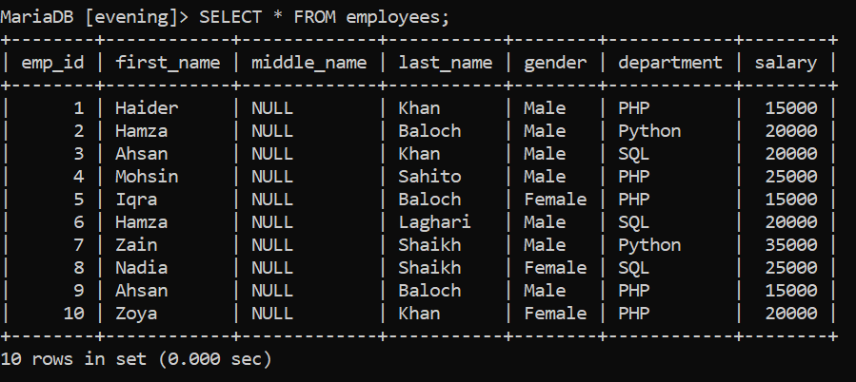

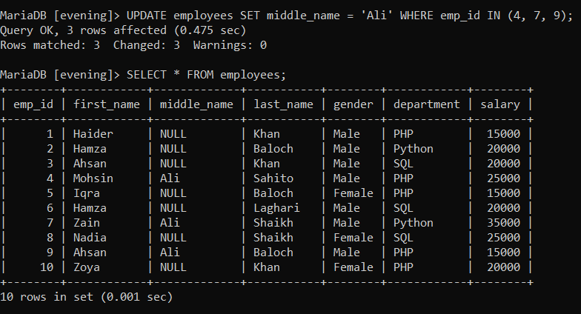

**Query #2 SELECT COLUMN:** For selecting particular field(s) in a table.

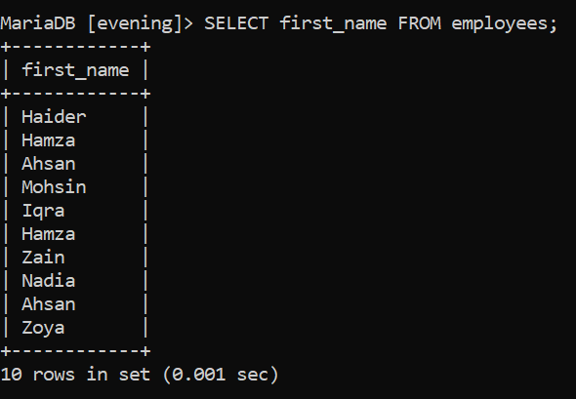

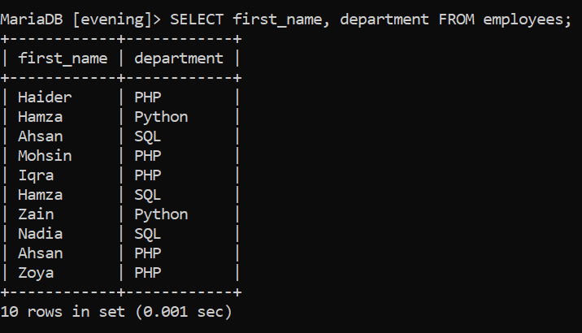

**Query #3 SELECT WHERE:** For selecting field(s) with particular value(s) in a table.

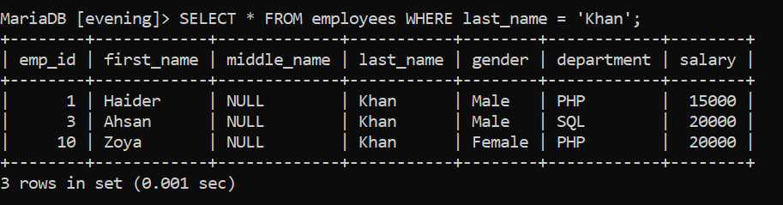

**Query #4 SELECT AS:** For giving alias to a column, which will show as column name in result set.

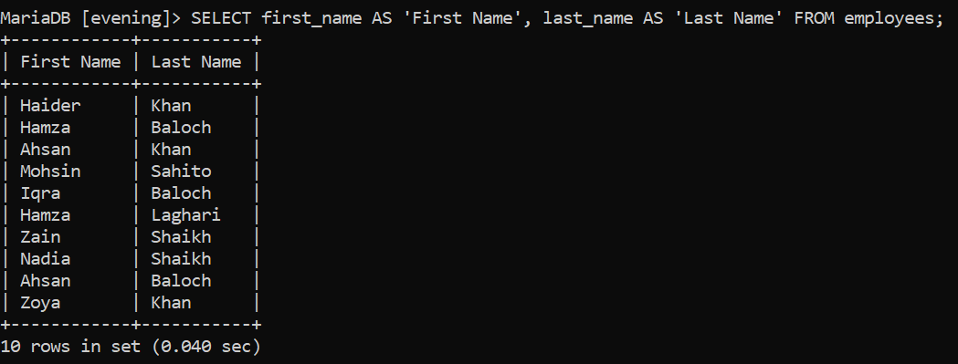

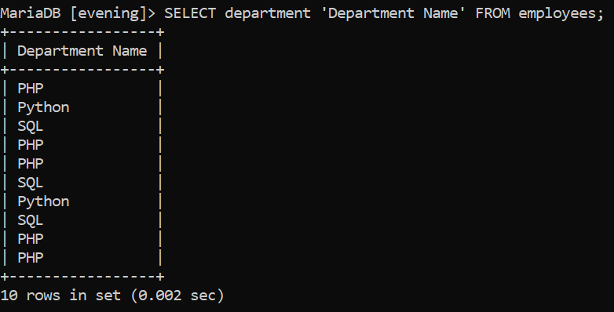

**Query #5 SELECT DISTINCT:** For selecting records in a column that are different or unique.

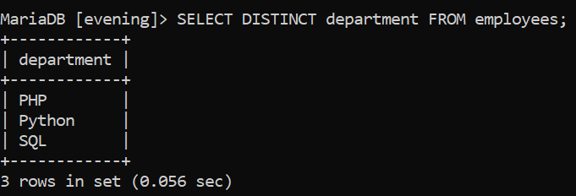

**Query #6 SELECT WHERE:** For selecting field(s) with particular value(s) in a table and using different operators to specify values.

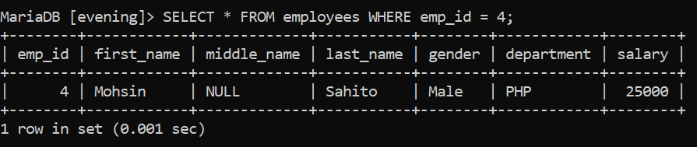

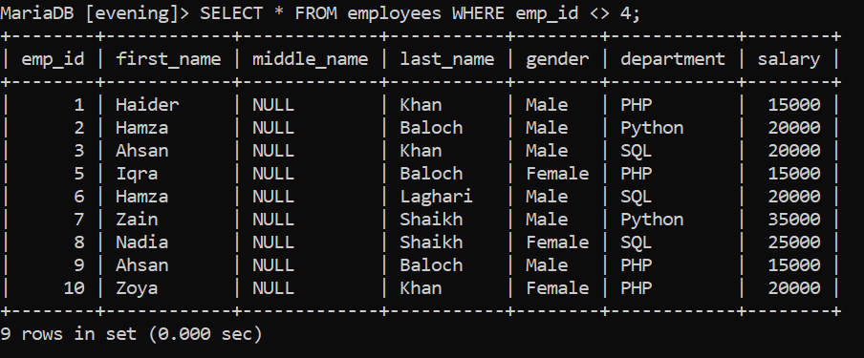

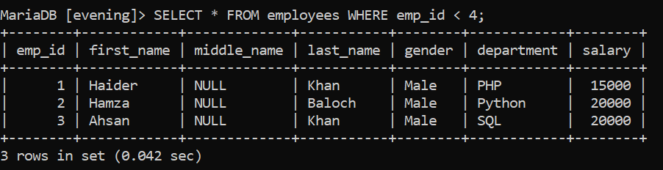

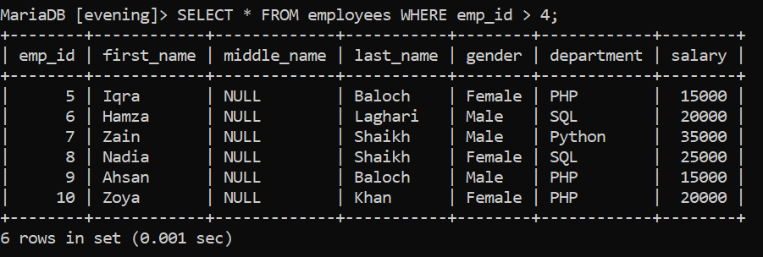

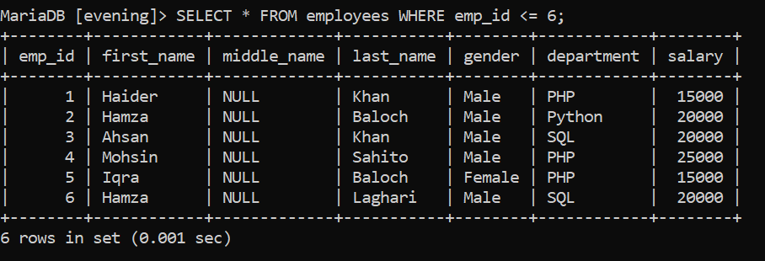

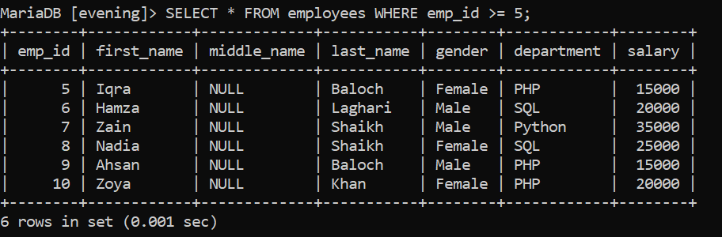

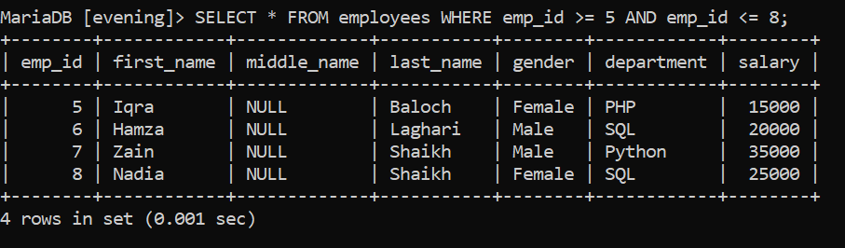

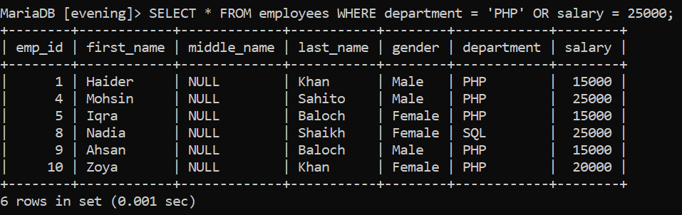

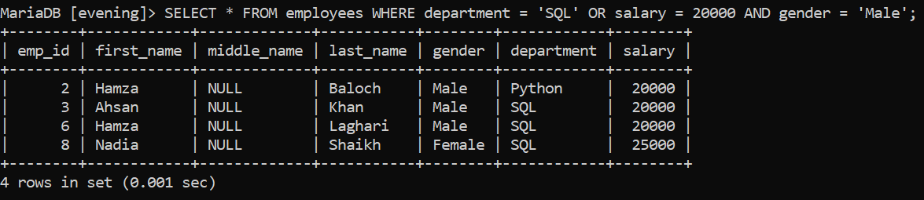

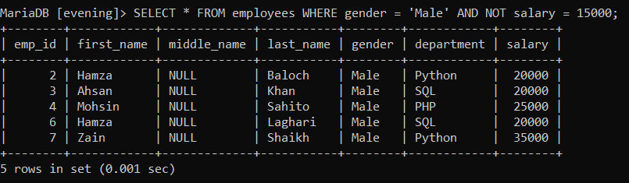

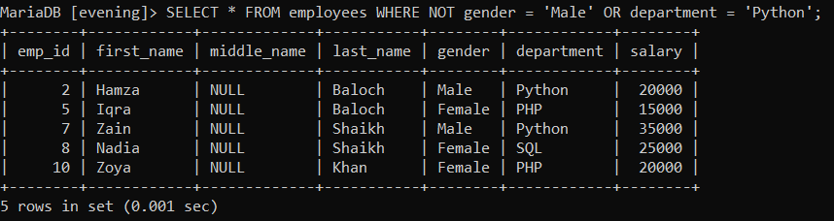

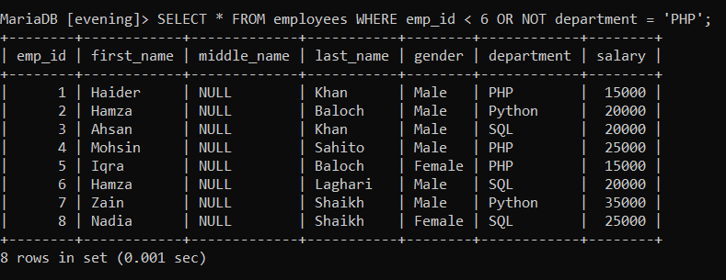

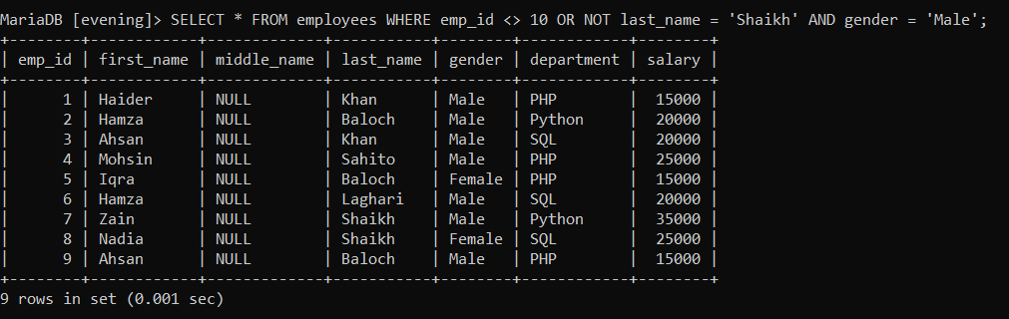

**Query #7 SELECT LIKE:** For showing values that match a pattern. The patterns are created with special characters “_” and “%”.

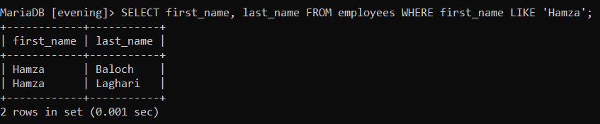

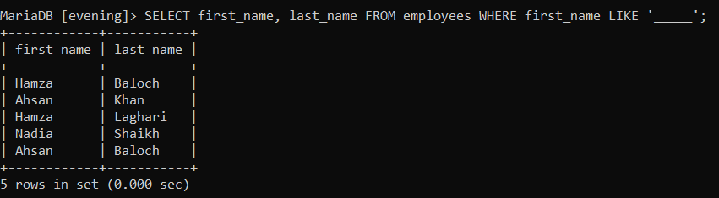

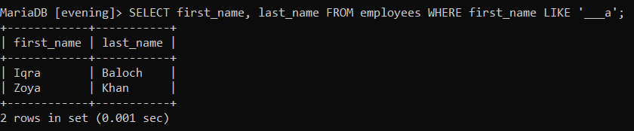

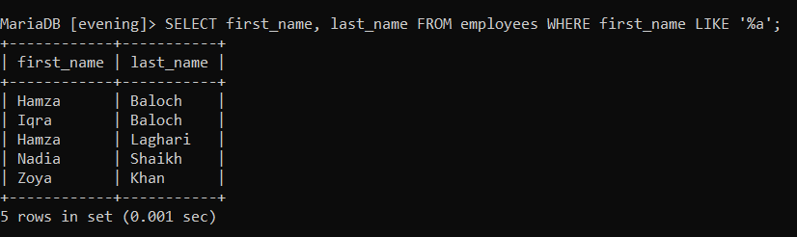

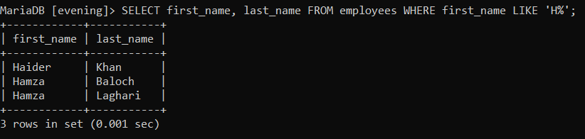

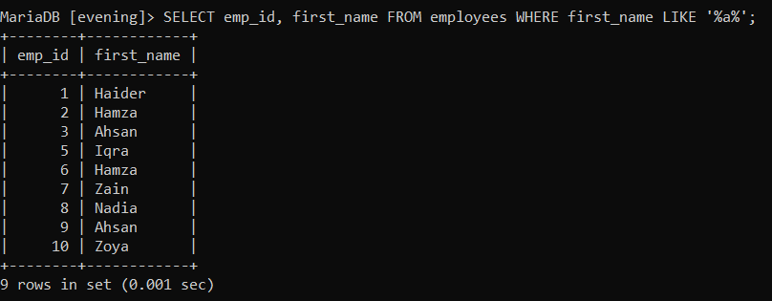

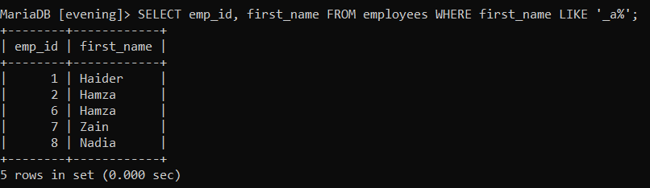

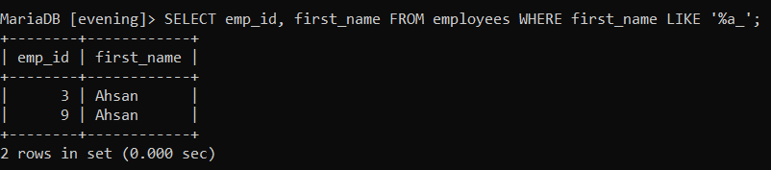

**Query #8 SELECT REGEXP/ RLIKE:** For also showing values that match a pattern. The patterns are created with special characters “^” and “$”.

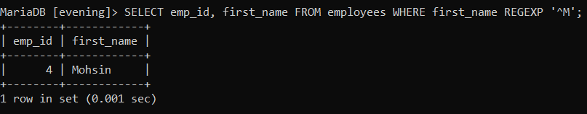

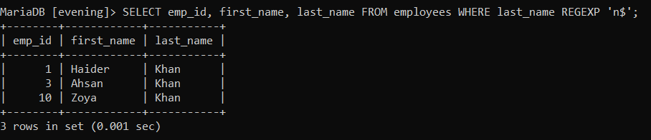

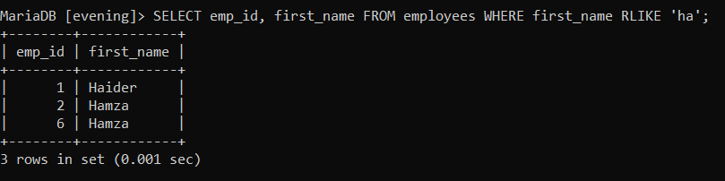

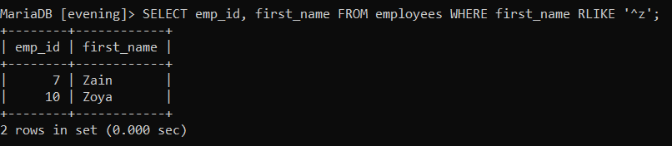

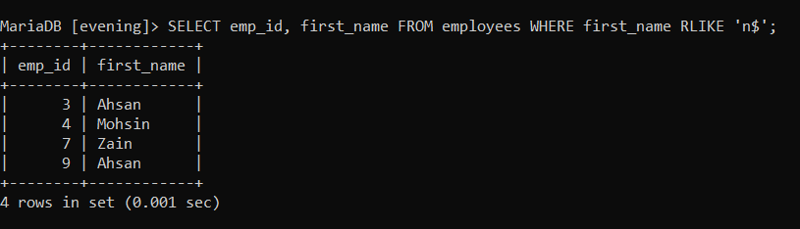

**Query #9 SELECT IS NULL / IS NOT NULL:** For showing missing or unknown values or not unknown values.

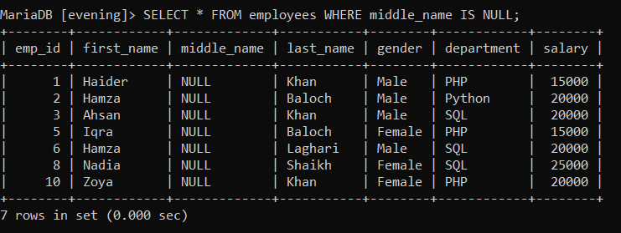

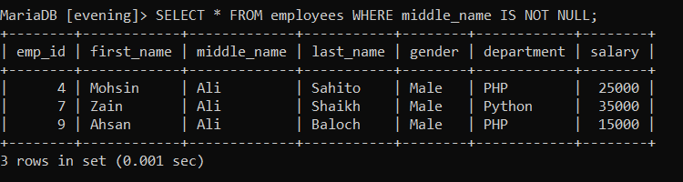

**Query #10 SELECT BETWEEN / NOT BETWEEN:** For showing values that are between and including a specified low value and high value.

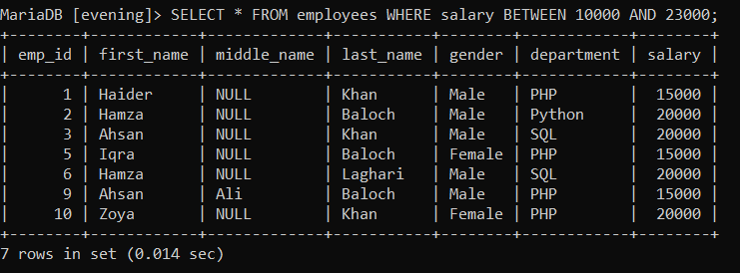

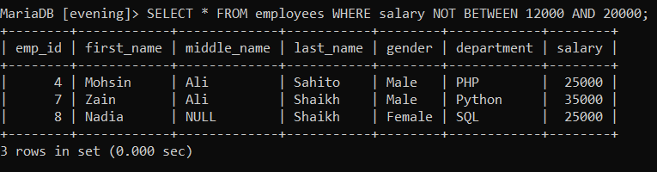

**AGGREGATE FUNCTIONS**

**Query #11 SELECT SUM():** For showing sum of record values of specified column.

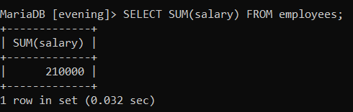

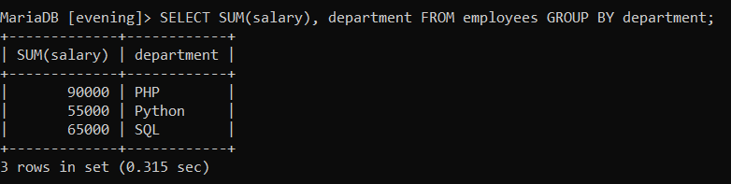

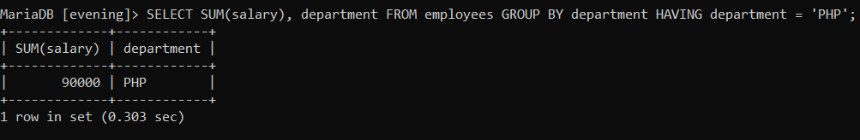

**Query #12 SELECTAVG():** For showing average of record values of specified column.

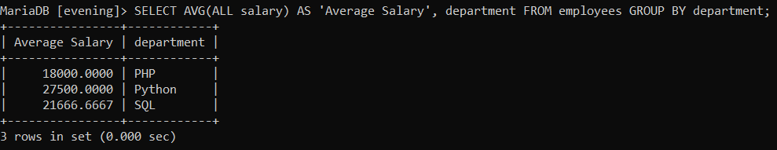

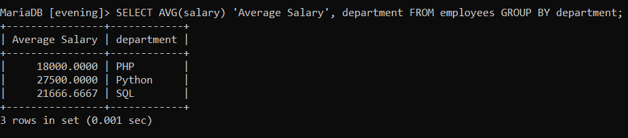

**Query #13 SELECT MIN():** For showing smallest record value of specified column.

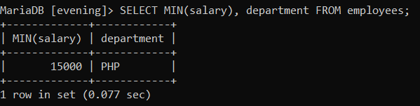

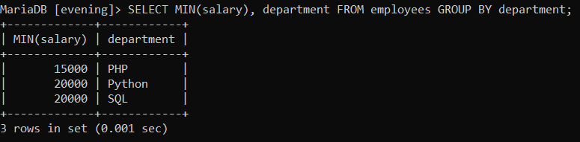

**Query #14 SELECT MAX():** For showing largest record value of specified column.

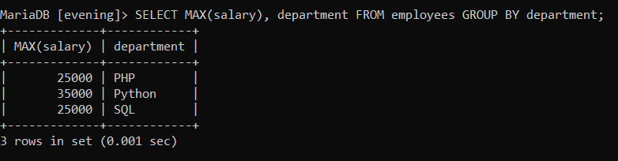

**Query #15 SELECT COUNT():** For showing quantity of record values of specified column.

